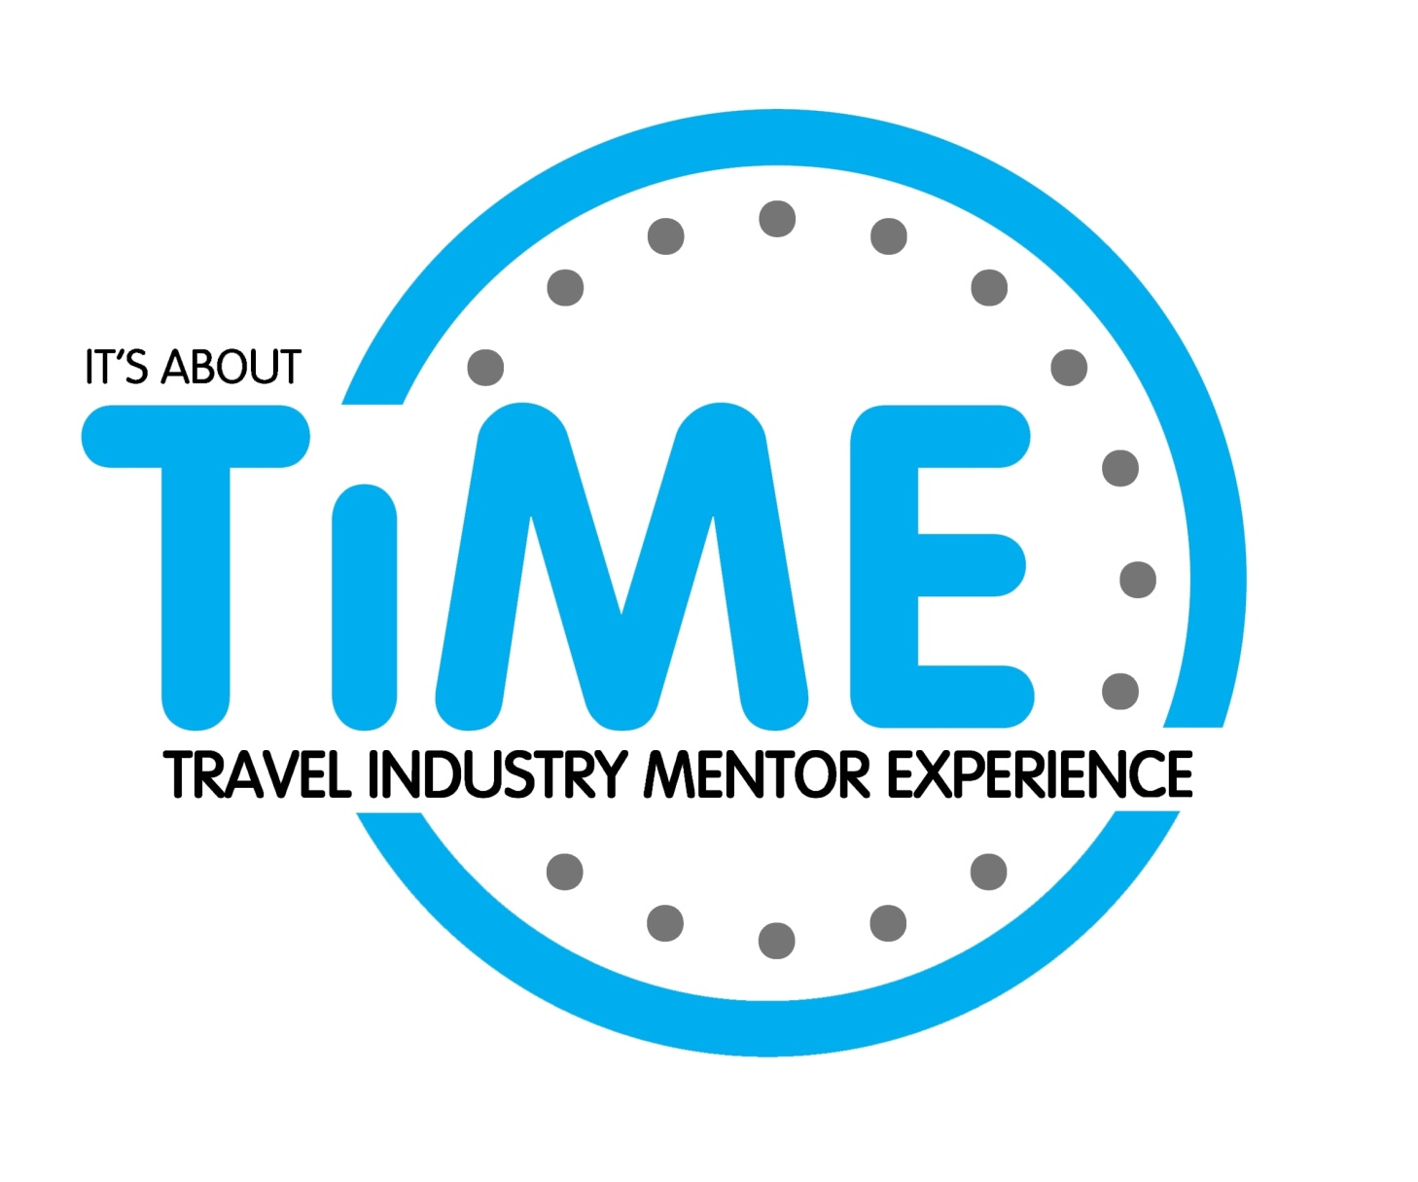
“Commercial in Confidence”
Mentor Expression of Interest

2019/2020

www.travelindustrymentor.com.au

Overview of Travel Industry Mentor Experience – TIME

The purpose and vision of TIME is:

"To provide knowledge, guidance and advice to aspiring individuals within the Travel and Tourism industry allowing them to advance and grow their career."

Targeting aspiring, mid-level management individuals who have three years or more experience in the travel and tourism industry, the aim of TIME is to offer development guidance, business skills and support sessions within a formal mentoring and peer collaboration environment.

Research tells us that the best employees are attracted to and stay within an industry, company or organisation that offers them career development.

By inviting the best and brightest to envision the work or job they would love to be doing and providing guidance, knowledge and expertise from an experienced mentor, TIME is instrumental in helping them achieve that advancement.

The TIME programme has become embedded in the development plans of many of Australia’s largest travel companies and has successfully graduated over 260 mentees since 2009.

Why be a Mentor?
Mentoring is a relationship which gives people the opportunity to share their professional and personal skills and experiences in a structured and professional way.

You’ll be surprised at how much you, as a mentor, will gain from the experience.

- You have the potential to change someone’s life
- You will help support valuable talent to stay within the travel industry
- It can reinforce the business and life lessons you’ve learnt
- It can connect you with other areas of the industry
- It helps set the tone for a collaborative and supportive travel industry

“The greatest good you can do for another is not just to share your riches but to reveal to him his own." Benjamin Disraeli.

The Programme
The TIME programme offers a one to one relationship based on encouragement, openness, mutual trust, respect and a willingness to learn and share.

One of the keys to successful mentoring is matching the mentee with a mentor who has the relevant skills and experience to meet the needs and objectives of the mentee.

To assist in this process, we ask that prospective mentors complete an Expression of Interest (EOI) form for review and approval by the TIME Committee.

Mentees are then matched with a suitable mentor, based on the criteria contained in these EOI Forms, (completed by both mentee and mentor), the mentee’s programme objectives and the mentor’s skill set and experience. As suitable mentors are found for each mentee, the mentors are contacted to ensure they’re available for the relevant intake.

All participants, mentors and mentees will be contacted to ensure they feel comfortable with their match. The Programme Coordinator (Secretariat) will be available throughout the programme to assist both mentors and mentees.

Programme Length and Inclusions:
- A 6 month programme;
- 12 sessions/meetings of approximately 2 hours duration;
- Time and place of meeting to be mutually agreed between mentee and mentor’
- Networking evenings with guest speakers;

Induction Workshop and First Meeting (2 hours)

The first meeting is an important meeting where mentors and mentees get to know the background of each other and discuss how best to work together.

The mentee will complete a NICE analysis document, outlining their strengths and weaknesses in various business and management skills. This will be sent to the mentor prior to the first meeting and will provide some or all of the framework to establish programme objectives for the mentee.

Final Meeting and Graduation:
Your final meeting, held before the Graduation ceremony, will review the objectives and achievements of the previous sessions.

The Graduation Evening provides congratulation and recognition for both mentees and mentors at the conclusion of their programme through:
- 2-3 minute speech by each mentee;
- Presentation of certificates;

Graduation Ceremonies and Networking Evenings 2019/2020
New mentees will be inducted into the programme during the year but will graduate at one of the four Graduation Ceremonies held during the year.

Programme Number Intake Dates: Graduation dates:
Programme 34 10 April 2019 30 October 2019
Programme 35 19 June 2019 19 February 2020
Programme 36 4 September 2019 8 April 2020
Programme 37 19 February 2020 26 August 2020
Programme 38 8 April 2020 14 October 2020
Programme 39 10 June 2020 February 2021
Programme 40 26 August 2020 April 2021

Networking and Graduation Events 2019/2020
30 October 2019
19 February 2020
8 April 2020
10 June 2020
26 August 2020
14 October 2020

TIME Conditions and Requirements
Networking Evenings
TIME invites all mentors to attend Networking evenings, however it is not a requirement. - except for the Induction and Graduation Evenings
Induction Workshop
All prospective Mentees and Mentors must attend their Induction workshop prior to commencing on the Programme

Airfares & Accommodation for Interstate Mentors
The cost of airfares and accommodation for interstate mentors will be borne by the mentor

Expenses
Some out of pocket expenses will be incurred during the length of the programme and these are to be borne by the mentor.

Frequently Asked Questions:

What about confidentiality?
Confidentiality is essential to enable the mentee to be open and ensure the kind of genuine relationship necessary for success. Both mentor and mentee sign a Confidentiality Agreement before programme commencement. Confidentiality ground rules are that nothing can be discussed outside the relationship without the other party’s agreement (aside from legal obligations). A code of practice for mentoring will also be made available.

Are mentors paid?
The role of the mentor is voluntary however by mentors showcasing and sharing their entrepreneurial experience, mentors will find this an invaluable experience - which will provide many unexpected gains personally and in business.

Will I be matched immediately following acceptance as a mentor?
As one of the keys to the success of TIME has been the matching of mentees with the “right” mentor, you may not be asked to mentor until the right mentee match enters the programme.

What if I am asked to mentor but my changes to my commitments won’t allow the time?
The Programme Coordinator will check your availability with you before matches are finalised.

Will I be matched with a mentee in my city?
Whilst the committee will endeavour to match a mentee with a mentor in the same town or city it is not always possible due to the requirements of the mentee and the specific expertise of the relevant mentor. This will be discussed with each party prior to finalising the mentorship.

What happens after the mentoring pairs are matched and each party advised?
There will be a formal induction (per listed “Intake Dates”). This is preceded by an initial workshop and meeting with your mentee. The formal conclusion of the relationship will be after six months. Informal extension of the relationship is up to both the mentee and mentor.

What if a mentoring relationship doesn’t work out?
To date, TIME has been extremely successful in matching mentees and mentors, however, we do understand that not all relationships will necessarily be successful. If a mentor or mentee wishes to end the relationship prior to the formal conclusion of the programme, the Programme Coordinator will seek feedback to assist in reassignment where relevant.

What’s the difference between mentoring & coaching?
While coaching and mentoring share a range of techniques, mentoring provides career guidance and longer-term support, as opposed to the relatively short-term and performance-related purpose of coaching. They are synergistic and complementary.

What’s the role of a mentor versus a manager?
Mentoring is not intended to replace the role of the manager. Whilst the manager is responsible for setting work goals and ensuring they are achieved, the mentor focuses on overall career development support.

Send this section – pages 7 to 13 and a Photo of yourself to:
TIME Secretariat:
time@travelindustrymentor.com.au

Expression of Interest – Mentor

Your Name
Business Name:
ABN:
Category of Business
Business Address
State: |  | Post Code:
Phone (Mobile): |  |  | Phone (Work)
Email:
Your Job Title:
Home Address:

Website URL:

Your Age Group:
 | 26 - 36 |  | 37 - 47 |  | 48 - 58 |  | +58

Formal Education Qualifications: Please detail here any degrees, diplomas, trade certificates that you may have.

Business Qualifications: Please list any business training programmes or courses that you have undertaken.

Professional Organisations/ Awards: Please list any professional organisations or committees of which you are a member or any major business or industry awards you may have won or been a judge

Business Experience: Please outline your current business/company experience. Please pay special attention to your Management experience within this organisation.

Business Industry: Please nominate the industry segment and role that best matches your business and current position.
Industry Segment | X | Role | X
Travel Agency- Retail |  | Consultant
Travel Agency-Corporate Travel |  | Team Leader
Event Management |  | Agency/ Department Manager
Wholesale Travel |  | Owner
Hotel |  | Sales/Account Executive/ Manager
Airline/ Aeronautical |  | Marketing Executive/ Manager
Consolidator |  | Product Executive/ Manager
Insurance |  | Finance Executive/ Manager
Technology |  | IT Executive/ Manager
Other |  | Other

About your wholly owned business

If you own a business, please nominate your business structure:

Sole Trader: |  | Partnership: |  | Company:
Years of Operation:
Is Your Business Home Based? |  | Yes |  | No
How many hours per week do you work in your business?
Describe your business:

Previous Company / Business Experience - other than the business you are working in right now, please list the last 3 Company / Businesses and your role - outlining your experience/ key accountabilities

Organisation | Role | Experience

If you are not currently employed by a company or in business, what was the last year you were in business and please outline the reasons for change?

Why be a Mentor?
Everyone chooses to mentor for a variety of reasons. Please give us an insight into why you would like to be considered a mentor in this programme?

Do you have any previous mentoring experience? Please detail.

What skills do you possess that you believe will add value to a mentee?

Please use this space to let us know about anything else you feel is relevant as we consider your application.

How did you hear about the TIME Programme?

 | Travel Daily |  | KARRYON |  | Travel Weekly
 | Travel Bulletin |  | Word of Mouth |  | Other (detail below)
Referred to the programme by:

I certify that the information provided in and supporting this application is true and correct.

Signed:
Dated:

Please return this completed form from page 8 to 13 to:
Manager, TIME Programme
time@travelindustrymentor.com.au

Privacy Statement
Any personal information provided to TIME is protected by the Commonwealth Privacy Act 1988. The information is essential to determine your eligibility for the Time Programme. TIME may disclose some of your personal information to a third party contractor who will monitor and deliver parts of the TIME programme. The information may be used to send you communications about business-related activities such as newsletters, flyers and invitations.

www.travelindustrymentor.com.au

